Winter 04| Event and Handlers

Learning objectives
- To develop handlers for a more complex script problem
- To learn to analyse a script problem.
- To be able to apply various types of form elements; to read out the information that was entered and to fill a form element with the proper information.
- To recognize variables and to be able to apply them.

Rich Internet Applications
This assignment is in co-operation with vid. In the vid classes you will be working on designing a rich internet application. This is about the possibilities that you have for visualizing information. On the internet you can find multiple examples of applications on-line in which the user can put together his own product. You are going to design and realize such a product. It is a RIA by means of which you can design your own T-shirt and order it.
Examples
On its website Nike has a similar product. Have a look at it to get some inspiration.
http://nikeid.nike.com/nikeid/index.jhtml
An order form for ordering special printed matter (prints on banners, adhesives, lettering, etc.) can befound on 123sticker.nl. Here you can also enter varous options, so that you can make your order exactly what you want.

In the next two classes you will have time for the assignment given below. You can work on this assignment independently. Do not wait until you have finished the design. First realize it technically, but do it such a way that the design can be adapted easily at a later stage.

Stap 1: Wireframe
Below you see the figure that will also be used in class:
Step 1
1
2 colour selection
3 picture selection*
4 picture size
small large
5 type of shirt selection
6 change text on shirt
change colour of text
order now!
* Picture is individual 24 bits PNG
after picture selection you see the picture again in picture size
the choice of steps is not necessarily convenient in this order

Step 2
Size
Colour
Picture
Model
Text on shirt
Order your t-shirt here and it will be delivered
Address
Postal code
Method of payment
Send

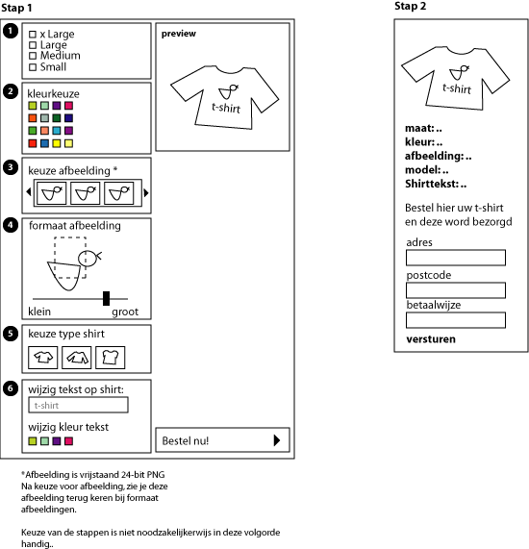

Step 2: Analysis
This assignment is best approached in the same way as last week’s assignment. Make an analysis of all variables and objects that you need and write down per screen in pseudo code what you need. In this case the division into screens is not so interesting. It is wise to formulate per form element. If you see them as individual elements, it is easy to work with them. It is, therefore, not so important in what order they are. On the basis of your design you can easily adjust your Flash file.

step 3: Creating the page structure by yourself
Now that it is clear what we are going to make and how we are going to approach it, the computer can be switched on. Make all pages in Flash. Make sure that each page is in its own frame. Use labels to name each framer. I use the names of the screens in the flowchart.

Stap 4: Realizing each screen
Screen 1:
form element 1: 4 radio buttons with the sizes. Use the radio buttons here, because you can never select more than1 size.

form element lement 2: 16 colour selections. This can also be done in another way, of course. When you want to use another interface, this is also possible. The important thing is that in any case you store a colour selection.
form element 3: Here you can choose from various individual pictures. How you represent these pictures depends on your design. The important thing is that they are 24bits png picture which you cut out yourself in Photoshop
form element 4: The selected picture appears in this form element. With the slider you can set the size in relation to the original. In this way you set the size in which the picture is printed on the t-shirt.
form element 5: Here you choose the type of t-shirt.
- Long sleeve
- Short sleeve
- Short sleeve tight
form element 6: In this form element you can change the text on the t-shirt and the colour in which the text is printed. Contrary to the picture you will have to use a button to change the text in the original. So you will have to add it.
preview: There is a preview that will change under the influence of how the various options are filled in, in conformity with the settings.
Screen 2:
In screen two you get another listing of all options that have been entered, as well as the final preview of your screen. Also a form will appear in which you can enter your personal data for the purpose of ordering the t-shirt. It is important that a check is included to see if all fields have been filled correctly.

Author: Roos Groenewegen
Season: Winter
Les number: 03
Date: 13-12-2006
Type of lesson: MME

